Children’s Folklore
1. | He has a hat in his hand. 
2. |   Ip dip dip /  My blue little ship /  Sailing on the water /  Like a cup and saucer,/  But you are not in it.
3. | 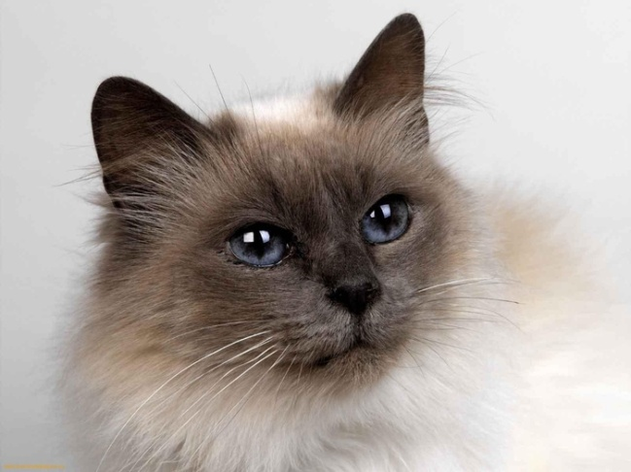  "Pussy-cat, pussy-cat,  Where have you been?”  "I’ve been to London  To look at the Queen.”  "Pussy-cat, pussy-cat,  What did you there?”  "I frightened a little mouse  Under her chair.”
4. | Red lorry, yellow lorry, red lorry, yellow lorry, red lorry, yellow lorry…  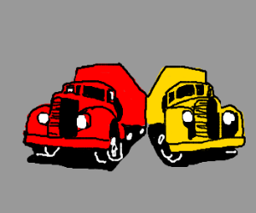
5. |   White, but not snow.  Sweet, but not ice-cream.  What is it?

